*Florida International University*

*School of Computing and Information Sciences*

Software Engineering Focus

Feature Document

User Story #**184,185,186,188**

**Team Member:**

Justin Lopez

**Product Owner(s)**:

Mohsen Taheri

**Mentor(s)**:

Mohsen Taheri

**Instructor**: Masoud Sadjadi

**User Story**

* As a user, when I visit the Neat website, I want to be presented with a simple and beautiful page so that I may be informed of Neat and its useage.

Acceptance Criteria

* Create Simple Landing/Homepage and structure #185
  + Image links (use relevant Google Play/Apple store images) to our Neat Application in the Apple Store/Google Play Store
* The navigation bar should match the colors/theme of the website. #186
  + Link to Online Tutoring Page
  + Link to About Us/About the Company Page
  + Link to “Neat Intelligence” page
* Create About Us section including relevant information #184
* Create Footer #188
  + Contains copyright statement for Neat
  + Email and Phone number for contact

**Use Case** #**184-186, 188 – Create Neat Website**

**Actors**

App user

Professors using the Dash

**Entry Conditions**

www.neatstudy.com

**Flow of Events**

1. Primarily a One-page site, with the home, about, service and contact us all on the landing page.
   1. User can scroll down to view information or click the appropriate titles on the navigation bar.
2. User can also click the Neatbot title to take them to a separate page which will be populated with the AI teams NeatBot and tutoring services or User Story #187.
3. Login would be used by professors to take them to the Teacher Dash or User Story #178.
4. Footer is located at the bottom of every page, User scrolls to get there.

**Use Case Diagram**

|  |
| --- |
|  |

**Sequence Diagrams**



## *^ Figure: “SendEmail” Sequence Diagram*



## *^ Figure: “GoogleMaps” Sequence Diagram*

**Class Diagram**



**Test Case**

**User Story #185 - Create Simple & Modern Webpage**

**System Tests:**

**Purpose:** To test the functionality of use case: #185 Modern Webpage

**Test ID: Webpage_001 (Sunny Day):**

Purpose:

* Ensure all anchors work, directing to individual sections

Precondition:

* NeatStudy.com is live and running.

Input:

* Click “Home”, “About”, “Services”, or “Contact”

Expected Result:

* Direct to those specific sections on the homepage.

Actual Result:

* Direct to those specific sections on the homepage.

______________________________________________________________________________

**Test ID: Webpage_002 (Sunny Day):**

Purpose:

* Ensure hyperlink to Team Page redirects

Precondition:

* NeatStudy.com is live and running.

Input:

* Click Team Page

Expected Result:

* Direct to the Team Page.

Actual Result:

* Direct to the Team Page.

______________________________________________________________________________

**Test ID: Webpage_003 (Sunny Day):**

Purpose:

* Ensure that emails are sending to the correct email addresses, with the correct subject and body text.

Precondition:

* The user is on the Contact Section and Neatstudy is running. The user has filled out all of the forms on the messaging page.

Input:

* The User fills in the user name, receiver addresses, message subject, and message body for the message that is to be sent. Then user presses the “Send Message” button.

Expected Result:

* The message should be sent to neatstudy@outlook.com with the correct subject and message body text.

Actual Result:

* The message was sent to neatstudy@outlook.com with the correct information.

______________________________________________________________________________

**Test ID: Webpage_004 (Rainy Day):**

Purpose:

* Ensure that emails are not being sent with erroneous receiver addresses/subjects/body text from the form.

Precondition:

* The User is on the Contact Section.

Input:

* User has not filled out a receiver email address, a subject, a message body, or all 3. Then user presses the “Send Message” button.

Expected Result:

* The email will not be sent due to a lack of the required parameters for message.

Actual Result:

* Server replied asking for necessary information to send email.

______________________________________________________________________________

**Visual User Guide**

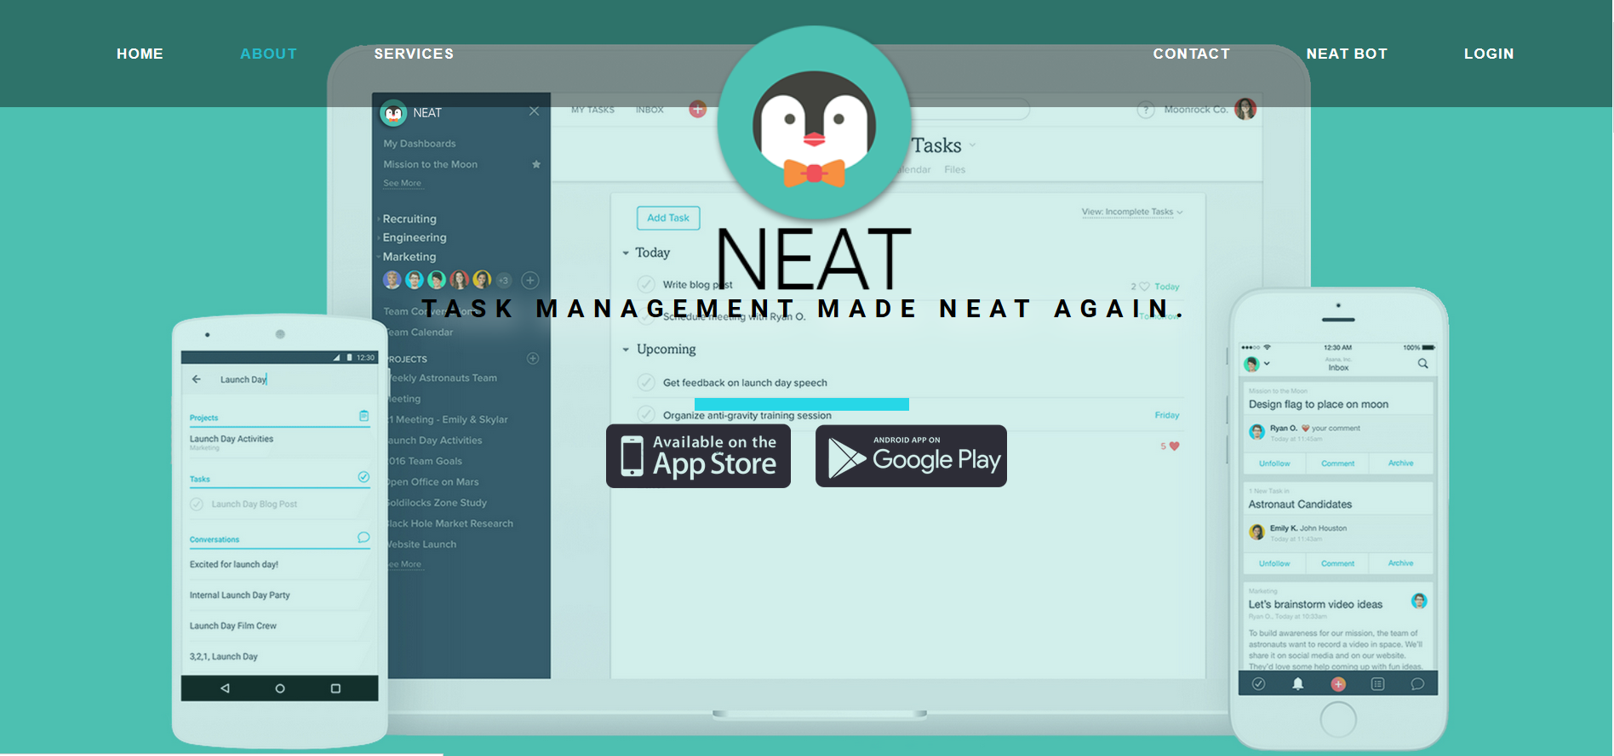

[[**Screencast of Webpage**](https://drive.google.com/open?id=0BxMLfu6jseL7bm8yQUJUeUdtQnc)**]**